HOTEL MANAGEMENTSYSTEM

Project Report



SUBMITTED BY STUDENTS OF BACHELOR OF COMPUTER APPLICATONS

(2021-2024)

**INSTITUTE OF TECHNOLOGY & SCIENCE,**

**MOHAN NAGAR, GHAZIABAD**

**AFFILIATED TO: CH. CHARAN SINGH UNIVERSITY, MEERUT**

|  |  |
| --- | --- |
| Student Name | Roll Number |
|  |  |
| Abhishek Singh | 210934106020 |
| Kumar Shubhum | 210934106159 |
| Tushar Singh | 210934106327 |

SUBMITTED BY: -

**CERTIFICATE**

This is to certify that **Tushar singh** has carried out the project work presented in this report entitled **“Hotel Management System”** for the award of **Bachelor of**

**Computer Applications** from **Institute of Technology & Science, Mohan Nagar, Ghaziabad**, under my supervision. The report embodies result of original work and studies carried out by Student himself and the contents of the report do not form the basis for the award of any other degree to the candidate or to anybody else.

Date: 11-03-2024

### **ACKNOWLEDGEMENT**

### We would like to express our profound gratitude to **Dr. Sunil Kumar Pandey**, the Director of ITS education group, and**Dr. Vidushi Singh**, the Chairperson of BCA, and our coordinator **Prof. Barkha Kakkar** for their contributions to the completion of our project titled “**Hotel Management System**”.

### We would like to express our special thanks to our trainer “**PROF. SAROJ KUMARI** " for the time and effort he provided throughout the project. Your useful advice and suggestions were helpful to us during the project’s completion. In this aspect, we are eternally grateful to you.

### **Students of Related Projects:**

**NAME ROLL NO**

Abhishek Singh 210934106020

Kumar Shubham 210934106159

Tushar Singh 210934106327

# **INTRODUCTION**

### In my project “**Hotel Management System**” I have tried to show how the data/information in hotels is managed. This is just an overview of management in hotels. It manages and maintains the records of customers, rooms, employees and drivers in the hotel. The project is aimed to maintain the day-to-day state of admission/vacation of Residents, List of employees, room details etc. Main objective of this project is to provide a solution for hotels to manage most their work using computerized processes.

This software application will help admin to handle customer information, room allocation details, Payment details etc.

The rooms have different categories like single bed, double bed etc. so their charges and records will be maintained accordingly.

This software has been made in a user friendly interface, so that anyone can add, delete, update the entries and handle all the transactions easily. As a security I have provided Admin username and Password.

The project, Hotel Management System is a desktop-based application that allows the hotel manager to handle all hotel activities online. Interactive GUI and the ability to manage various rooms, employees, drivers and customers make this system very flexible and convenient. This application gives managers the power and flexibility to manage the entire system from a single online system. Hotel management project provides room booking, staff management and other necessary hotel management features. The system allows the manager to post available rooms in the system.

**OBJECTIVE**

### The objective of the Hotel Management System is to develop a project which maintains booking of rooms, providing drivers, etc. It is a windows based application to be implemented in Java

The Purpose of the whole process is to ease the daily or regular activities of the Hotel Management into an automatic computerized retrievable process. The daily activities includes the Room activities, Entering details of the new customer check in, To allocate a room as per the customer need and interest, Recording the checkout time and details, Releasing or Empty of room and to record the process in a computer system for future.

Main objective of this project is to provide a solution for hotels to manage most their work using computerized processes. This software application will help admin to handle customer information, room allocation details, Payment details etc.

* Keeping records of admission ofcustomers.
* Facilities provided by hotels are fully utilized in an effective and efficientmanner.

FEATURE

1. Hotel Room Bookings andReservation
2. Front DeskOperations
3. Managing GuestProfile
4. User Privilege and securitycontrol
5. Keeping a tab on guest check-in check-outstatus
6. Maintenance of hotelrooms.
7. Providing a user friendlyinterface.

ANALYSIS

Study Of Current System-

Current System of Hotel Management is fully based on paperwork. Hotel Management has to manage all records of customers and rooms on paper.

Problem and Weakness Of Current System-

Paperwork is a tedious job. There can be delay and the problem of human error in allocating rooms and providing resources.

# HISTORY

Hotel Management Systems are able to automate the process of hotels. It is useful for authorities which keep track of all the users registered. The authority can hotel packages room detail and availability of rooms, online booking and other packages.

The following steps that give detailed information of the need for electronic managements are: Performance

During the past several decades, the records are supposed to be manually handled for all activities. The manual handling of records is time consuming and highly prone to error. To improve the performance of the hotel management system, the computerized system had to be undertaken.

Efficiency

The basic need of this application is efficiency. The website should be efficient so that whatever the user submitsanydetailtheapplicationisupdatedimmediatelyandautomatically.Theserecordswillbeuseful for othersinstantly.

Control

The complete control of the electronic system is under the hands of authorized persons who have the password to access the system and illegal access is not permitted. Control is entirely in the hands of the administrator and the other members have the right to see the records not to change any transaction entry.

Security

Security is the main criteria for electronic hotel management systems. Since illegal access may corrupt the database and ensure protection of the stored data.

## Cost Beneﬁt Analysis

* Role Based ScreenAccess
* The roles can be any of thefollowing:
* *Administrator Role*- is for provisioning of Register/Update/Remove/TransferContract.
* *Data Entry role*– for entering of basic formdata
* *Supervisory role*– for review/approval/rejection/modification ofdata
* *Decision making role*– viewing of report and decisionmaking

**Contribution**

Hotel Management Software is programmed to enable HR professionals for managing the data and information of the company’s employees on a regular basis. The easy information regarding the employees is including contact details, investment details, and much more.

*Accuracy:*

Your system must be able to accommodate your employees and various customers or guests at your hotel. Once a good system is in place, you will have an accurate record of the check-in and check-out status of a customer. An automated system minimizes the possibility of human error, as the only real factor is whether employees remember to clock in and out.

*Record-Keeping:*

Another feature of a hotel management system is that it can be used to keep detailed and accurate records. These records can be stored in a main database on site,online or in an outside record-keeping facility.

Record-keeping can help you monitor trends such as how much overtime you're paying and how many employees participate in your company retirement plans

# ADVANTAGM OF HOTEL MANAGEMENT SYSTEM

* Sometime it happens that the rooms get booked soon when one visits the place therefore user can make advance booking using this system.
* It saves user time in searching a room.
* The system is useful as it calculates an exact cost of rooms for requested number of days.
* It saves organization resources andexpenses.
* This system is effective and saves time and cost ofusers.
* It is less time consuming and provides maximumaccuracy.

# DRAWBACKS OF HOTEL MANAGEMENT SYSTEM

* The booking process usually requires a customer identity, which the system cannot detect.
* It requires a reliable internet connection

## Feasibility Study

To analyze whether the software will meet organizational requirements Feasibility isdefined as the practical extent to which a project can be performed successfully. Toevaluate feasibility, a feasibility study is performed.

To determine whether the software can be implemented using the current technology and within the specified budget and schedule A feasibility study is a preliminary investigation of a proposed system to decide whether the system can run smoothly with the organization.

To determine whether the software can be integrated with other existing software.benefits that are expected and to decide will the organization go for it.

**Three Types of feasibility study**

1. *TechnicalFeasibility.*

Ascertains that the technology chosen for software development has a large number ofusers so that they can be consulted when problems arise or improvements are required

1. *OperationalFeasibility.*

Analyzes whether users will adapt to a new software. Determines whether the organization is satisfied by the alternative solutions proposed by the software development team

1. *EconomicFeasibility*

Cost of hardware, software, development team, and training. Feasible only if tangible and intangible benefits outweigh the cost. The cost for proposed online shopping system is outweighing the cost and efforts involved

# REQUIREMENT SPECIFICATION

User Requirements

There should be software which allocates rooms automatically and maintains records of customers.

System Requirements

There should be a database backup of the hotel management system. There should be a Java supported framework for the system. Operating system should be WindowsXP or a higher version of windows.

User Interface

The User interface required to be developed for the system should be user friendly and attractive.

There are two sets of java APIs for graphics programming:

AWT (Abstract Windowing Toolkit) and Swing.

* AWT API was introduced in JDK 1.0. Most of the AWT components have become obsolete and should be replaced by newer Swingcomponents.
* Swing API, a much more comprehensive set of graphics libraries that enhances the AWT, was introduced as part of Java Foundation Classes (JFC) after the release of JDK 1.1. JFC consists of Swing, Java2D, Accessibility, Internationalization, and Pluggable Look-and-Feel Support APIs. JFC was an add-on to JDK 1.1 but has been integrated into core Java since JDK1.2.

For the development of this project both hardware and software were required. The hard required is any machine compatible for running the softwares and resources required.

Software Requirements

* + OperatingSystem Windows10
  + FrontEnd Java,NetBeans
  + BackEnd MySQL

Hardware Requirements

* + Desktop PC or aLaptop
  + Printer
  + Operating System – Windows10
  + Intel® CoreTM i3-6006U CPU @2.00GHz
  + 4.00 GBRAM
  + 32 and 64-bit operating system, x64 basedprocessor
  + 1024 x 768 monitorresolution
  + Keyboard andMouse

Class Diagram

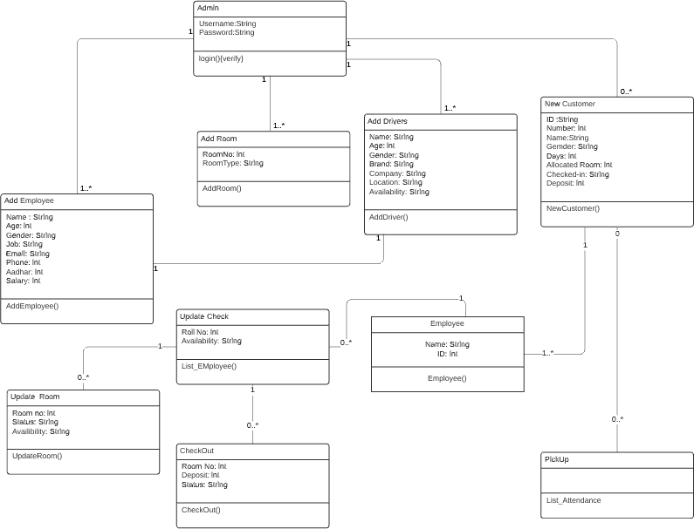

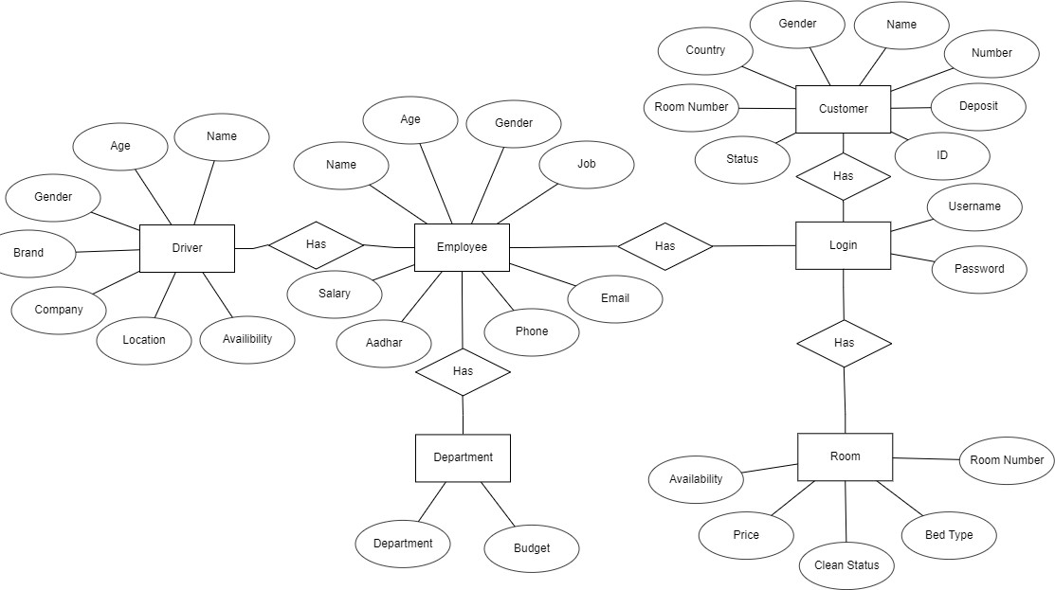

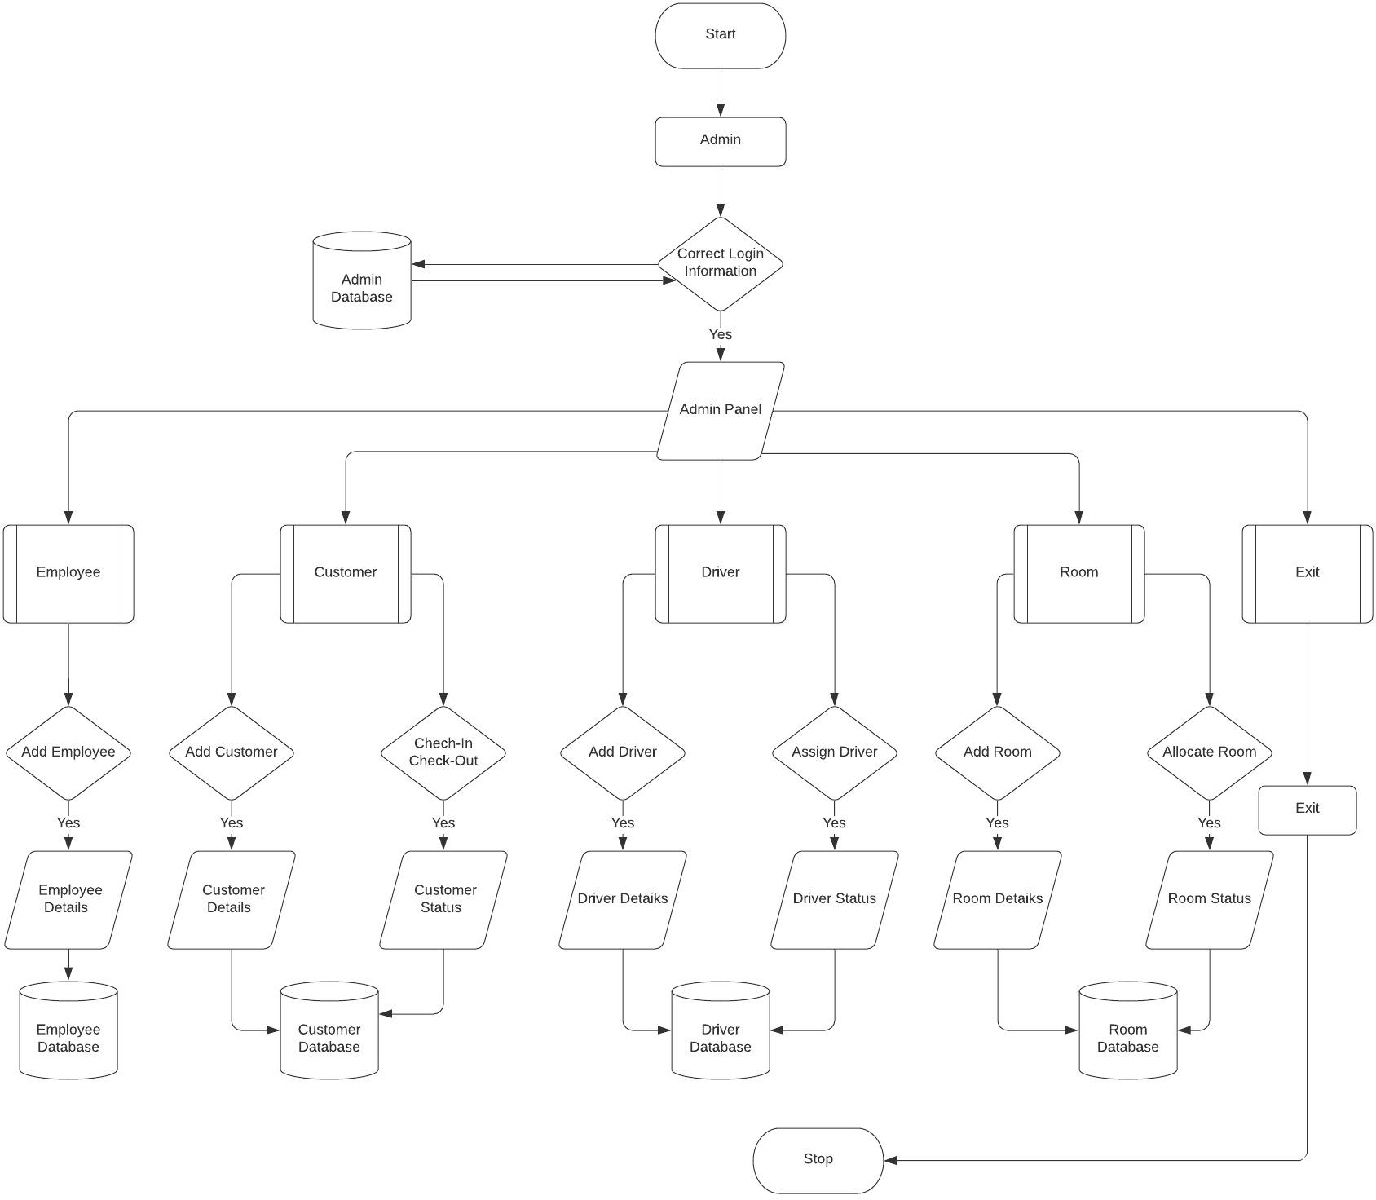

Hotel Management System (Main Page)

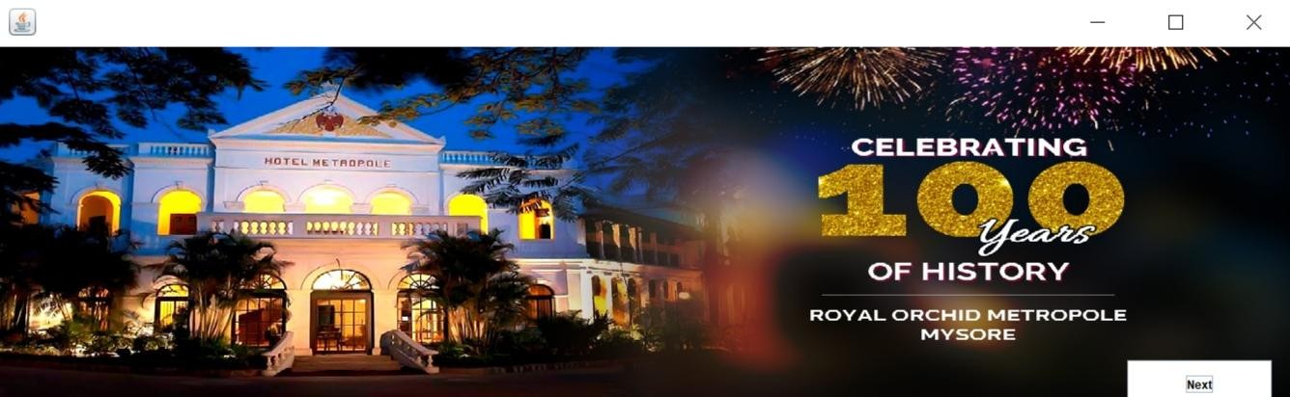

Login

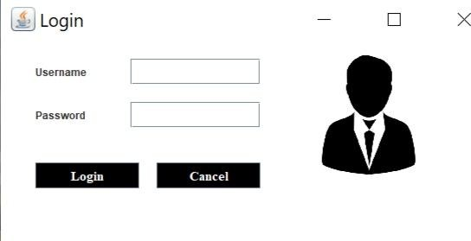

Dashboard

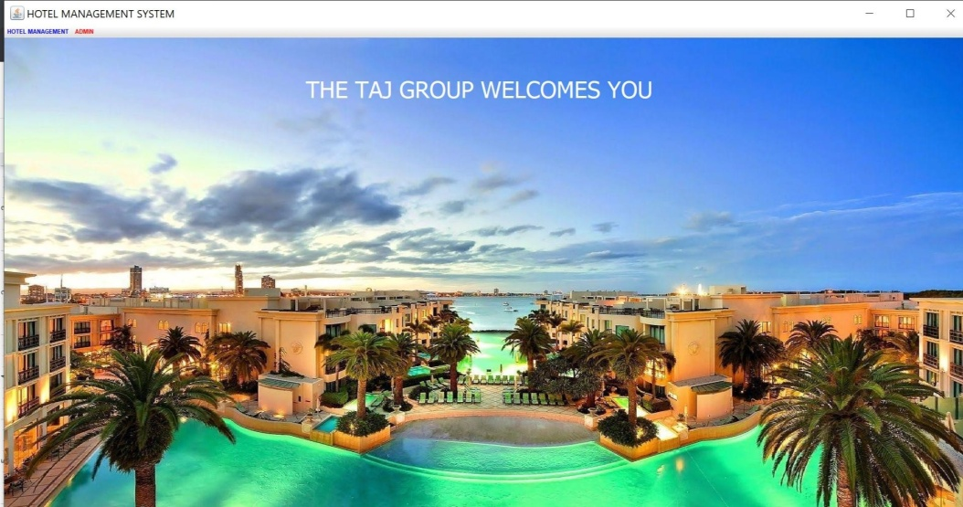

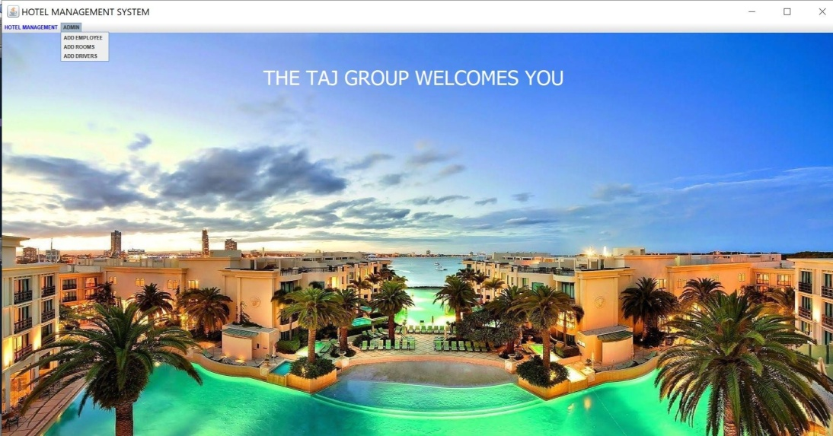

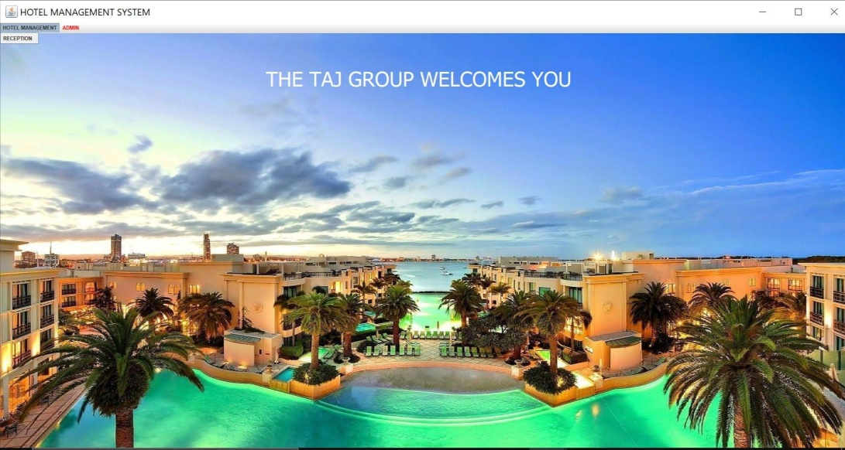

Reception

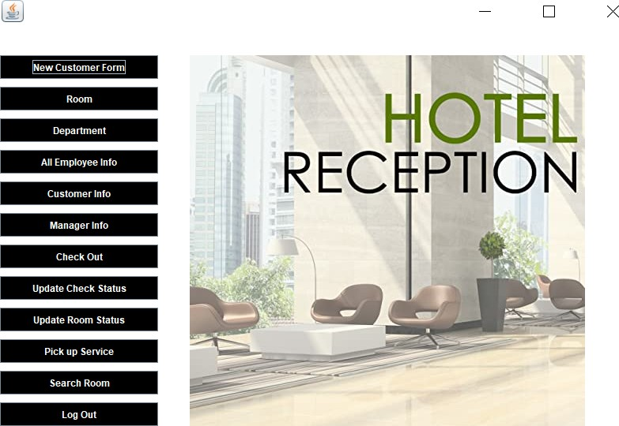

New Customer Form

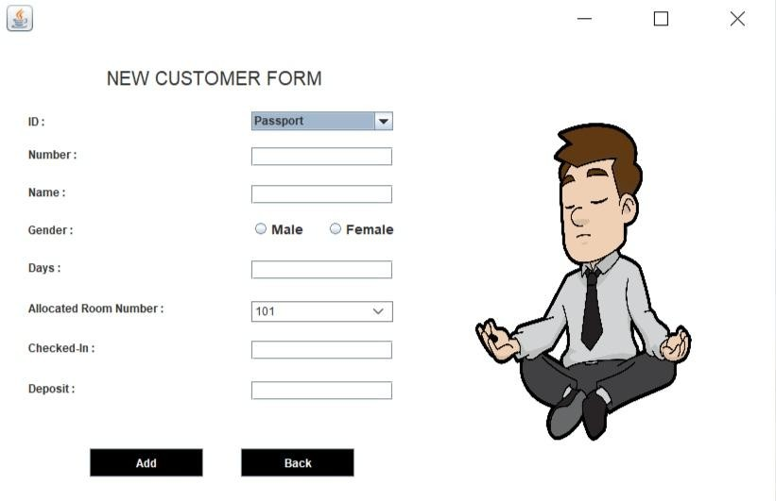

Room

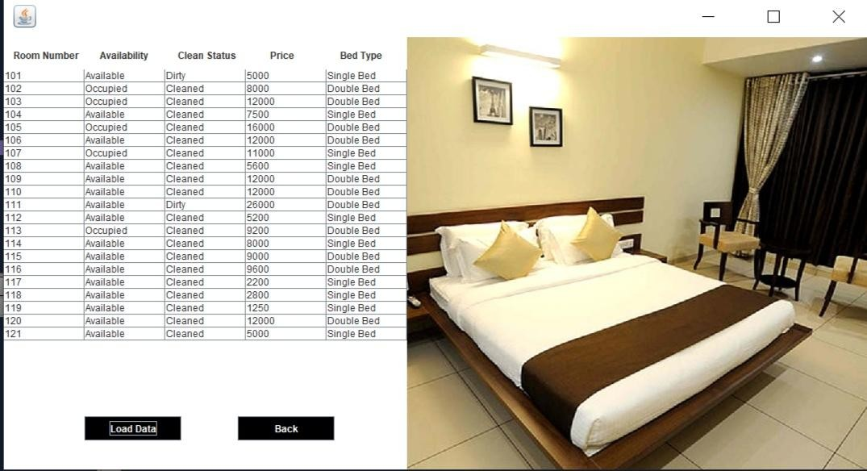

Department

Employee

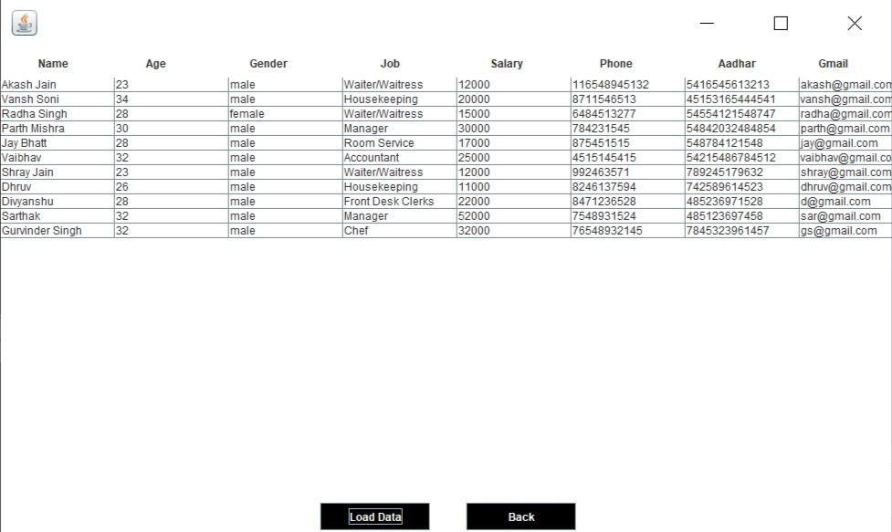

Customer Info

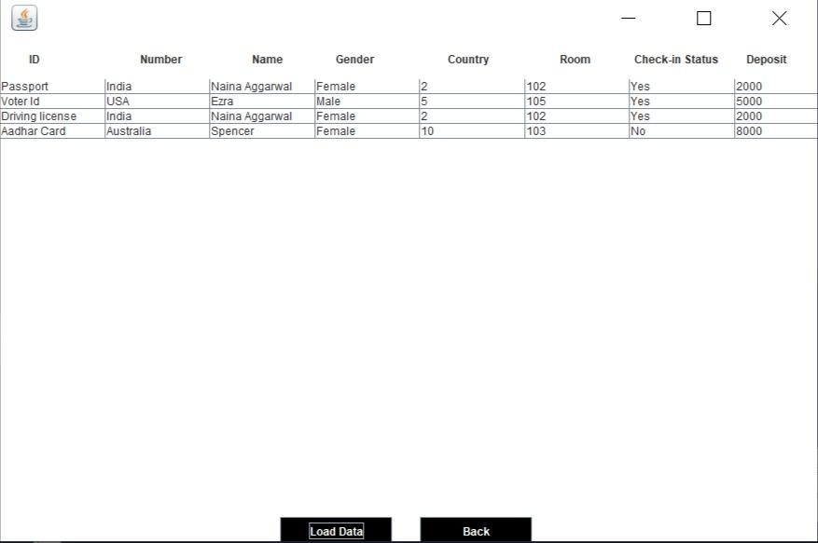

Manager Info

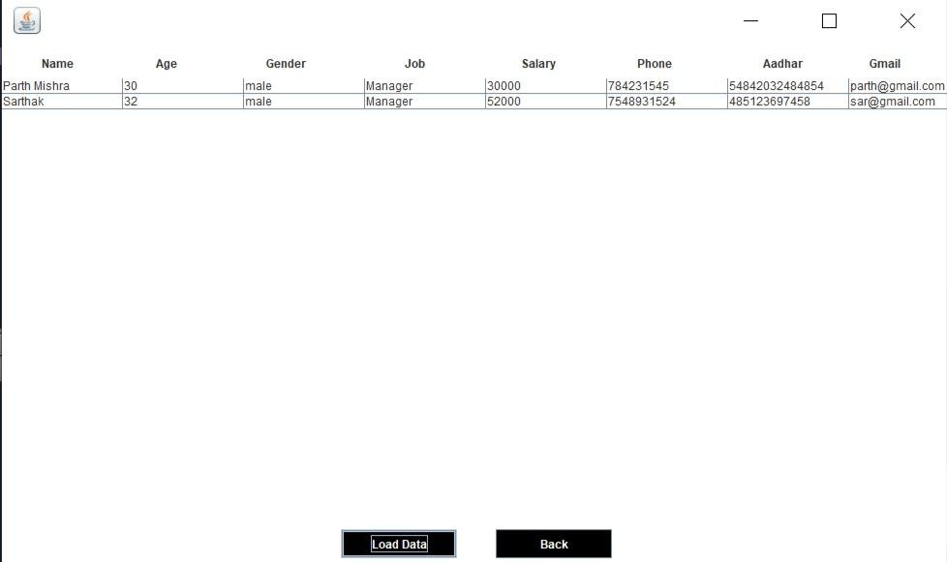

CheckOut

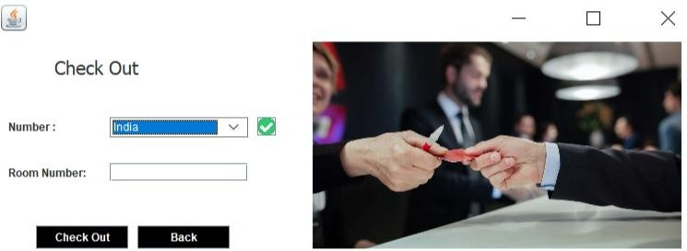

Update Check Status

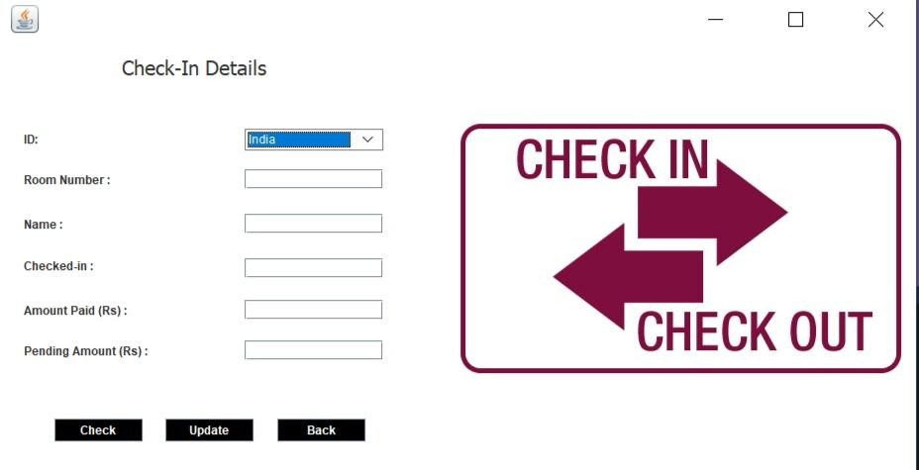

Update Room Status

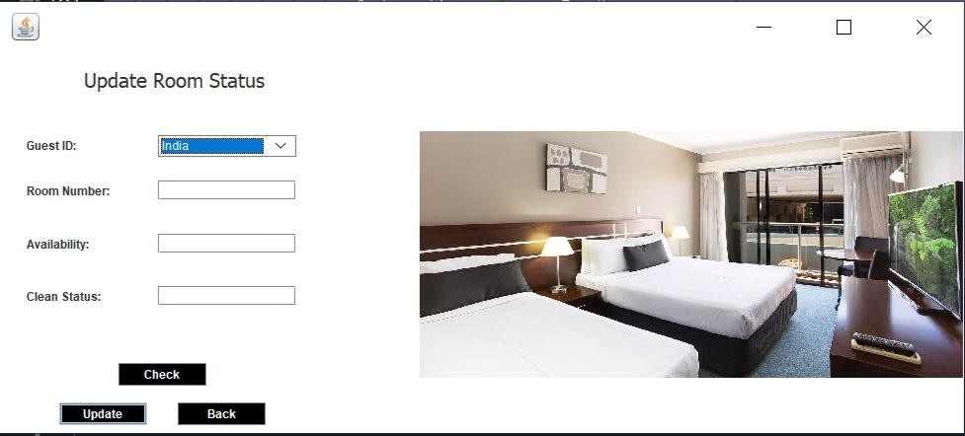

Pick Up Service

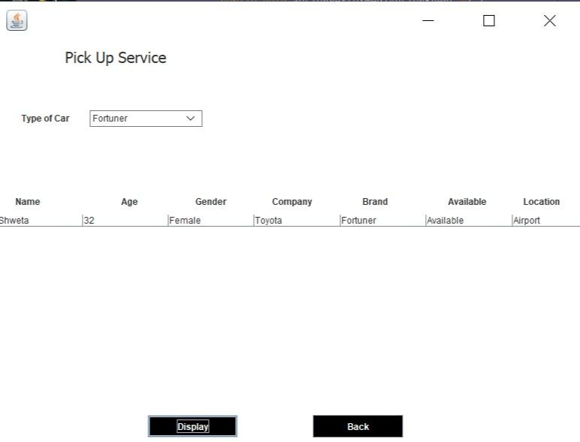

Search Room

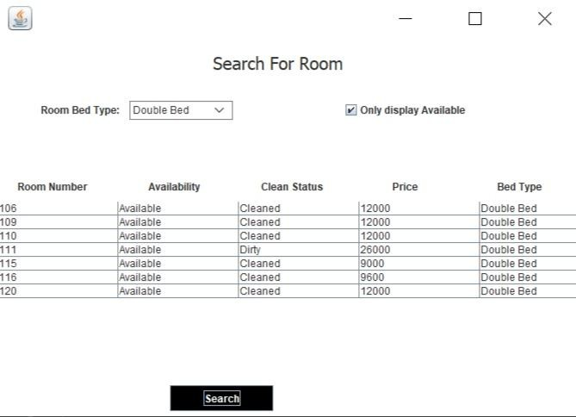

AddEmployee

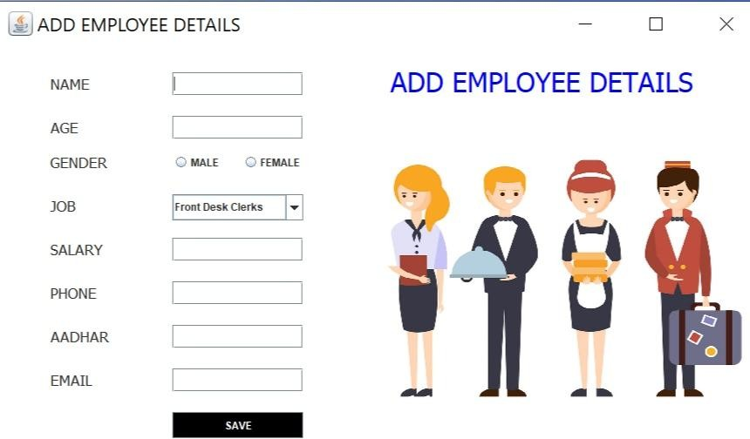

Add Rooms

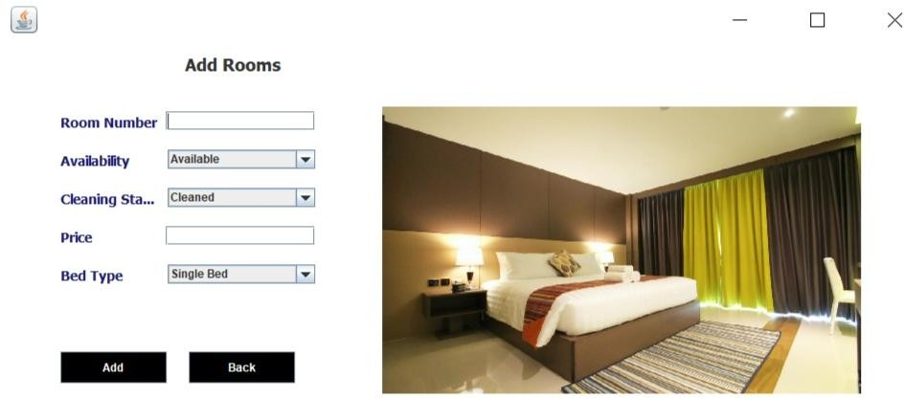

Add Drivers

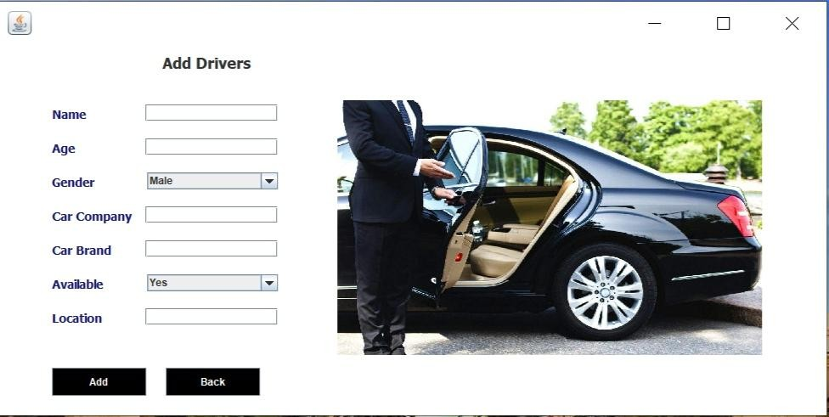

**TT\**

**TESTING**

*Unit Testing*

Unittestingisatestingtechniqueinwhichmodulesaretestedindividually.Smallindividual units of source code are tested to determine whether it is ﬁt to use or not. Diﬀerent modules of games are put to test while the modules are being developed. Here modules refer to individual levels, players,scenes

*Integration Testing*

Integration testing is the technique in which individual components or modules are groupedtogetherandtested.Itoccursaftertesting.Theinputfortheintegratedtesting, are the modules that have already been unittested.

*System Testing*

Systemtestingisconductedontheentiresystemasawholetocheckwhetherthesystem meetsitsrequirementsornot.‘ValarMorghulis’wasinstalledondiﬀerentsystemsandany errors or bugs that occurred wereﬁxed.

*Acceptance Testing*

User Acceptance is deﬁned as a type of testing performed by the Client to certify the systemwithrespecttotherequirementsthatwasagreedupon.Thistestinghappensinthe ﬁnalphaseoftestingbeforemovingthesoftwareapplicationtotheMarketorProduction environment.

# FUTURE SCOPE

The world is changing rapidly and so is the meaning of the Hotel Management System. Today hotel management is not only confined to hotels but has gone deep into tourism, catering, clubs, etc making it a very paying and an exciting career option.

With the rapid growth of the hotel industry pushed forward by foreign and domestic tourism and business travels, the demand for well trained and quality personnel too has gone up high. India is one of the preferred tourist and travel destinations. Approx 4.4 million tourists visit our country every year. The growth of 20% has been recorded in the tourist and hospitality industry over a few years and more growth is expected in coming years. At present, there are about 200 millions of jobs available in the industry, out of which 20% of the job opportunities are in India.

The Hotel Management System has a lot of enhancement options. In future more features may be added category-wise. It may try to analyze the user behaviour and preferences and accordingly suggest. All concepts can be applied to make the Hotel Management System more efficient.

REFERENCM

[www.youtube.com](http://www.youtube.com/)www.google .com